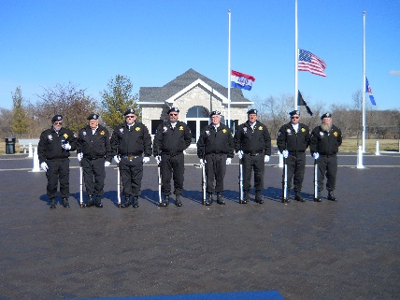
Branson Veterans of America 913
Honor’s Scholarship
Application must be completed in full
Please Print Neatly

Dear Applicant:

This scholarship is available and renewable up to a maximum of eight (8) semesters. Renewal of this scholarship is contingent upon completion of a current application and confirmation that your grade point and enrollment have been met.
Two $1000.00 scholarships will be given per year. Payments will be made to your college prior to the start of Fall Semester. After 2022 this application will be online at Bransonveteransofamerica.com

Eligibility
- Must be enrolled in at least your second year of College or Any Veteran returning to College.
- Application must be completed in full or will not be considered.
- Return application by or before March 10, 2023. Applications must be postmarked no later than March 10, 2023

Requirements
- Completed application
- Applicant must have/had a relative living or deceased in the Military.
- A student evaluation letter from a college advisor, teacher or administrator testifying to your talents, financial need, GPA (at least 3.00) and seriousness of purpose.
- Typed Essay of 500 words.
What is the most important change our country is currently facing? (i.e., immigration, gun control, economy, etc.) Detail both positives and negatives of these changes and how the changes affect the common American, and what you or I do to embrace or negate these changes.

- Mail application to:
BVA Chapter #913
Attn: Honor Scholarship Chairman
P.O. Box 632
Branson, MO 65615-0632

Name: __________________________________________________________

Mailing Address: __________________________________________________

City: _________________State: ________________Zip: ____________

Date of Birth: ______________

Phone: __________________________________________________________

Name of College Enrolled At: ___________________________________

Address of Colleges Bursars Office: ____________________________________________

Student Number or ID: _________________________

Current GPA: ________

Full Time Student (Hours) ____________ Part Time Student (Hours) ___________

Intended Major: _________________________________________________

Do plan on working while attending college _______

How many approximate hours do you work weekly _____

Parent/Guardian Name: ____________________________________________

Parent/Guardian Place of Employment: ________________________________

How many other family members are currently enrolled in college ____________

