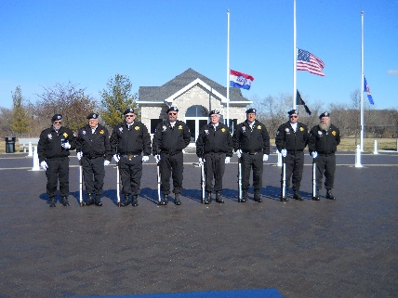
Vietnam Veterans 913
Honor’s Scholarship
Application must be completed in full
Please Print Neatly

Dear Applicant:

This scholarship is available and renewable up to a maximum of eight (8) semesters. Renewal of this scholarship is contingent upon completion of a current application and confirmation that your grade point and enrollment have been met.
Up to two $750.00 scholarships will be given per year. Payments will be made to your college prior to the start of Fall Semester. After 2020 this application will be online at Bransonvva913.com

Eligibility
- Must be enrolled in at least your second year of College or Any Veteran returning to College.
- Application must be completed in full or will not be considered.
- Return application by or before July 12, 2020. Applications must be postmarked no later than July 12, 2020

Requirements
- Completed application
- A student evaluation letter from a college advisor, teacher or administrator testifying to your talents, financial need, GPA (at least 3.00) and seriousness of purpose.
- Typed Essay of 500 words on: New Question will be added soon.
- Mail application to:
VVA Chapter #913
Attn: Honor Guard Chairman
P.O. Box 632
Branson, MO 65615-0632

Name: __________________________________________________________

Mailing Address: __________________________________________________

City: _________________State: ________________Zip: ____________

Date of Birth: ______________

Phone: __________________________________________________________

Name of College Enrolled At: ___________________________________

Address of Colleges Bursars Office: ____________________________________________

Student Number or ID: _________________________

Current GPA: ________

Full Time Student (Hours) ____________ Part Time Student (Hours) ___________

Intended Major: _________________________________________________

Do plan on working while attending college _______

How many approximate hours do you work weekly _____

Parent/Guardian Name: ____________________________________________

Parent/Guardian Place of Employment: ________________________________

How many other family members are currently enrolled in college ____________

